Tumor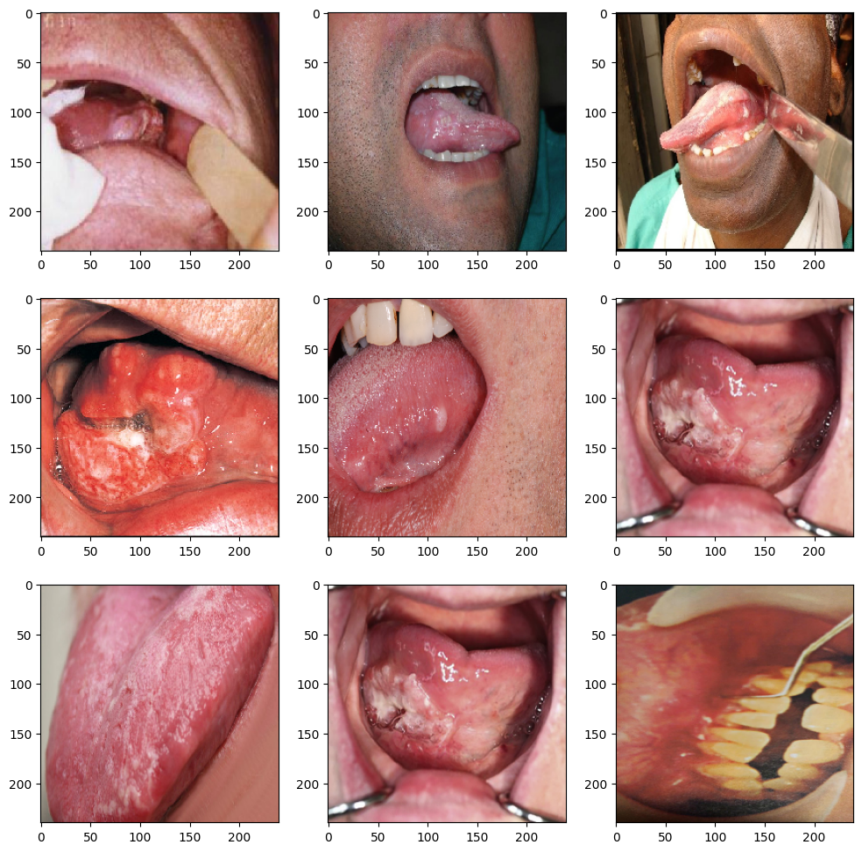Non-Tumor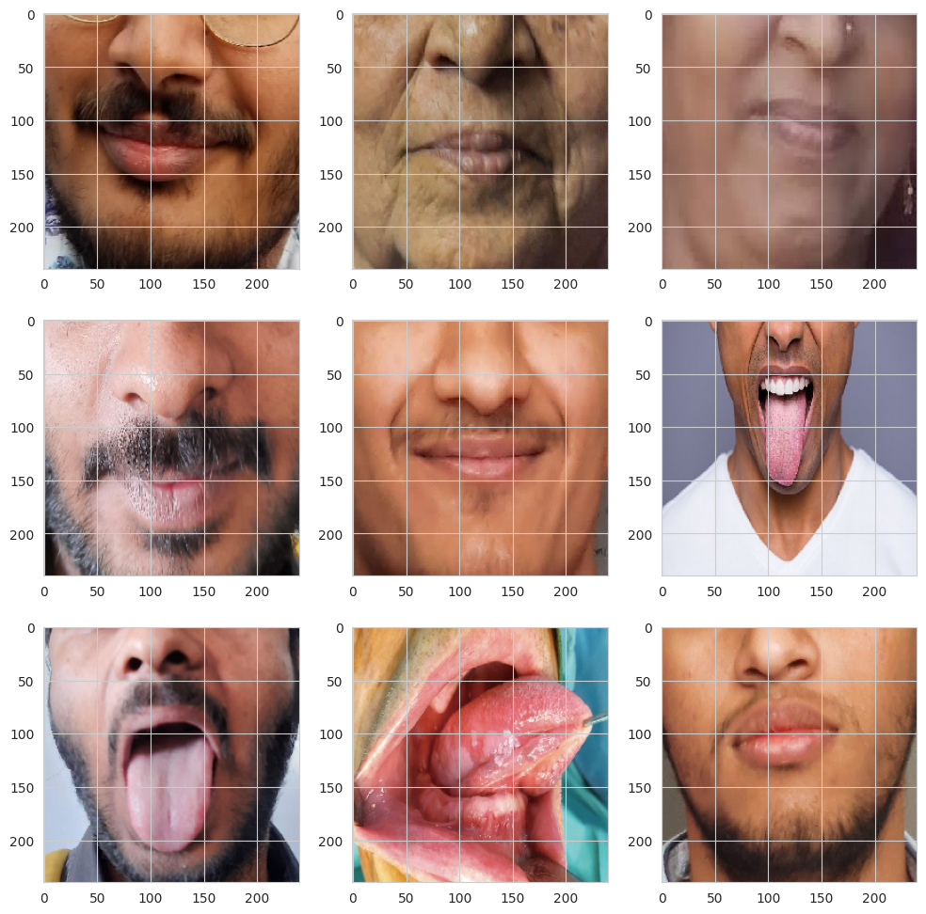

Baseline Model CNN

Model: "model"

_________________________________________________________________

Layer (type) Output Shape Param #

=================================================================

input_1 (InputLayer) [(None, 240, 240, 3)] 0

conv2d (Conv2D) (None, 119, 119, 32) 896

max_pooling2d (MaxPooling2 (None, 59, 59, 32) 0

D)

conv2d_1 (Conv2D) (None, 29, 29, 32) 9248

max_pooling2d_1 (MaxPoolin (None, 14, 14, 32) 0

g2D)

flatten (Flatten) (None, 6272) 0

dense (Dense) (None, 64) 401472

dropout (Dropout) (None, 64) 0

dense_1 (Dense) (None, 1) 65

=================================================================

Total params: 411681 (1.57 MB)

Trainable params: 411681 (1.57 MB)

Non-trainable params: 0 (0.00 Byte)

**VGG16**

Model: "model_1"

_________________________________________________________________

Layer (type) Output Shape Param #

=================================================================

input_2 (InputLayer) [(None, 240, 240, 3)] 0

block1_conv1 (Conv2D) (None, 240, 240, 64) 1792

block1_conv2 (Conv2D) (None, 240, 240, 64) 36928

block1_pool (MaxPooling2D) (None, 120, 120, 64) 0

block2_conv1 (Conv2D) (None, 120, 120, 128) 73856

block2_conv2 (Conv2D) (None, 120, 120, 128) 147584

block2_pool (MaxPooling2D) (None, 60, 60, 128) 0

block3_conv1 (Conv2D) (None, 60, 60, 256) 295168

block3_conv2 (Conv2D) (None, 60, 60, 256) 590080

block3_conv3 (Conv2D) (None, 60, 60, 256) 590080

block3_pool (MaxPooling2D) (None, 30, 30, 256) 0

block4_conv1 (Conv2D) (None, 30, 30, 512) 1180160

block4_conv2 (Conv2D) (None, 30, 30, 512) 2359808

block4_conv3 (Conv2D) (None, 30, 30, 512) 2359808

block4_pool (MaxPooling2D) (None, 15, 15, 512) 0

block5_conv1 (Conv2D) (None, 15, 15, 512) 2359808

block5_conv2 (Conv2D) (None, 15, 15, 512) 2359808

block5_conv3 (Conv2D) (None, 15, 15, 512) 2359808

block5_pool (MaxPooling2D) (None, 7, 7, 512) 0

flatten_1 (Flatten) (None, 25088) 0

dense_2 (Dense) (None, 64) 1605696

dropout_1 (Dropout) (None, 64) 0

dense_3 (Dense) (None, 1) 65

=================================================================

Total params: 16320449 (62.26 MB)

Trainable params: 1605761 (6.13 MB)

Non-trainable params: 14714688 (56.13 MB)

**visualkeras**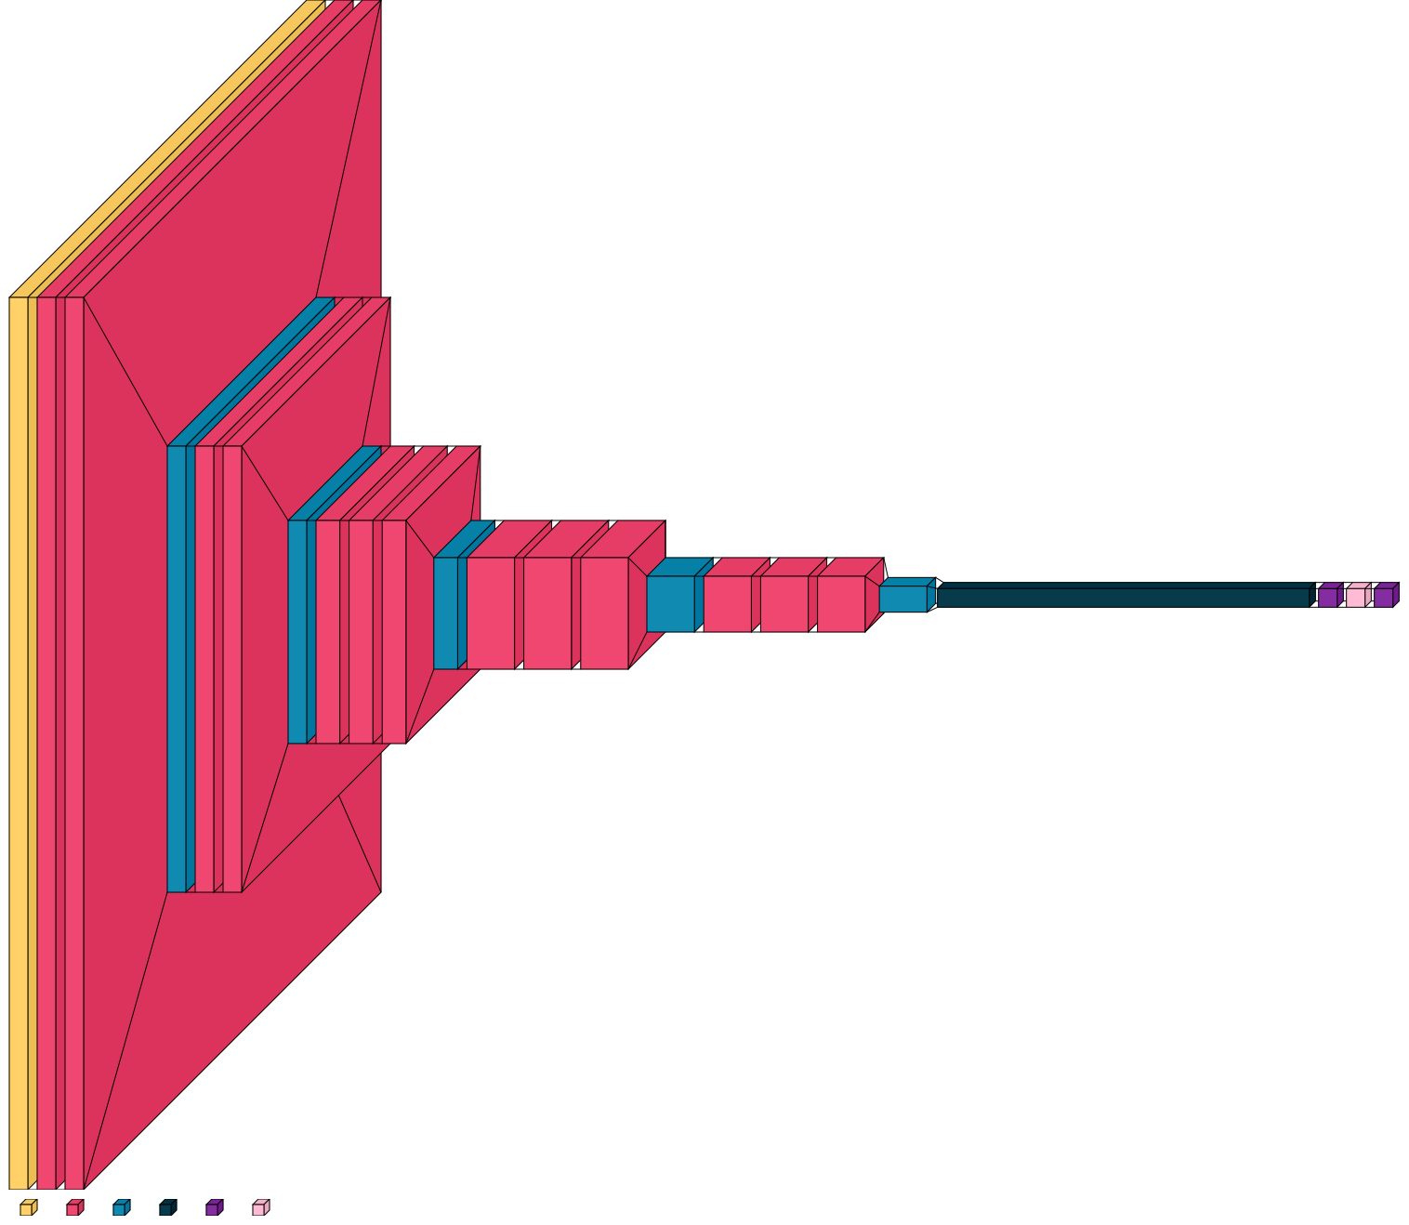Optimizer :AdamV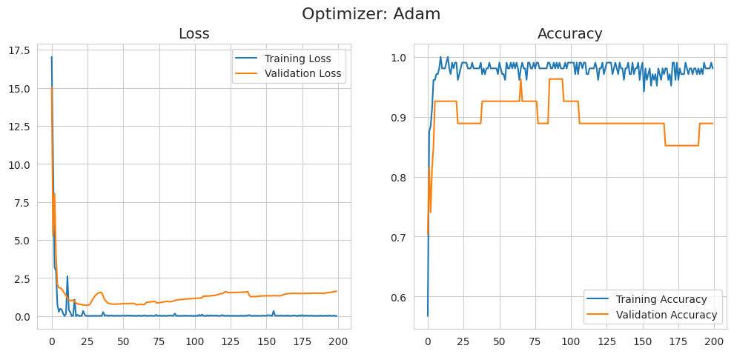

Confusion Matrix